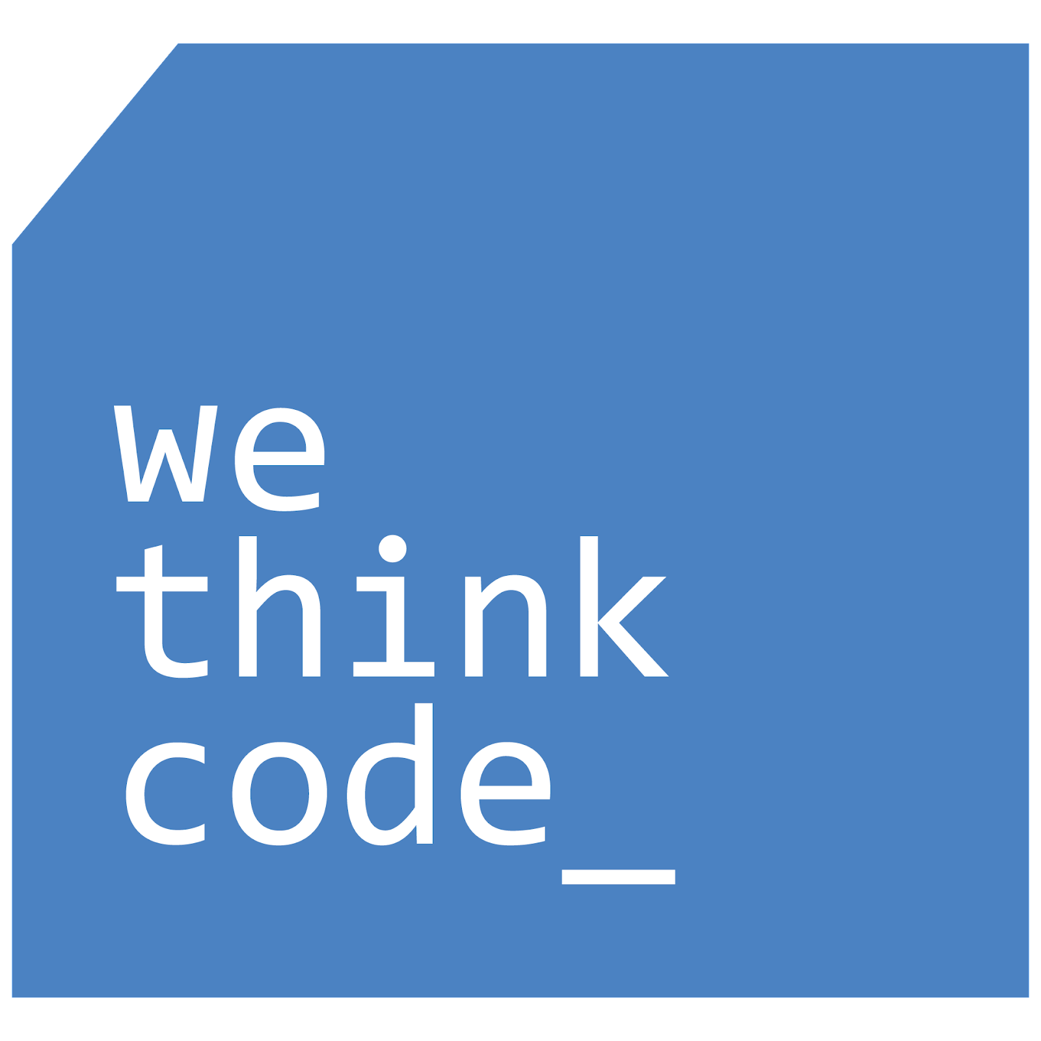
WeThinkCode_ Mentorship Agreement

This agreement is to help your group and your mentor align on what your engagement will entail over the next few months. This helps to set you up for success early on.

Use this document to:
- Agree on frequency and type of communication
- Define expectations and roles of both parties
- Define some specific goals you’d like to achieve through this mentoring relationship.

Communication:
How often will you meet/ communicate for official mentorship meetings?  Minimum is 1 hour every two weeks but you may choose to connect with your mentor more often. | I think we should start with 1 hour a week as a “required” meeting time. We’ve started with Friday at 12pm but that can change. It would be useful to meet in that format to catch up with goals that we set as a group, like technical improvement. But I find that during second year there’s a few things to juggle especially at the beginning so lets try and fit it within everyone’s shedule.
What channels of communication will you use for your meetings?  Eg. Google Meet, Whats app, Zoom | Google meeting is fine with me, camera’s are optional but I would recommend turning them on.
Contact outside of official meetings  Is your mentor comfortable/ do they have capacity if you contact them with questions or challenges outside of official meetings?  What platform of communication is suitable? | This is a tricky one. Of course I do this because it’s something I would’ve appreciated when I was in your shoes; I also can’t afford to let my passion burn me out. So I think as you get to know me you’ll understand that I’m not always instantly available But I will always try my best to get back to you guys. My core hours at work are 9am to 3pm (So I would actually appreciate it if we could more our meeting time outside of this, personally I love a good 7am meeting lol).But out side of that I’m available 7am – 9am and then 3pm – 6pm. These are times I can say I’ll be checking Slack and actively responding, But you can always leave a message for me outside of those times and I’ll get back to you. And I think it’s important that we stick to Slack and Google Meets for communication.

Expectations and Roles:

Meeting Preparation  Is there any meeting preparation required for meetings? / Creating an agenda to provide session structure?  Who will be responsible for this? | After the first meeting, we might agree on things we could each do better to improve on something,this doesn’t have to be some incredible achievement but maybe you want to improve you HackRank and and test taking skills, I’m sure I can solve a few of those challenges with your help while I share my screen.  So be prepared to speak, and we’ll use that meeting to report back on what you’ve done in the 2 weeks to improve on the goals you’ll set in the first meeting. Each of you will be responsible for this, I would prefer that you create a system where each week one of you is responsible for finding a tool to send a meeting invite to everyone. Try and practice making it easier for yourself (Automation, hint hint nudge nudge).
Recording meeting details and outcomes  Who is responsible for taking notes and sharing next steps after each meeting?  We suggest this sits with the mentees but up to you all to decide. | I don’t really have a preference but I would be a bit cautious because if we record meetings then some one is responsible for storing those recordings. Unless someone says otherwise; I’d say we don’t record.
General Expectations for meetings  Ie. What will make for a valuable interaction for both parties? | Mentees:  Mentor:  I’d hope to see someone master a skill they might have either thought they were comfortable with or are struggling with.  And as someone who is meant to share industry knowledge I know how important it is to be able to communicate effectively, especially early on in your career is this can be something as important as technical skill.  It sounds like I’m contradicting myself but like with all things there is a balance.

Goals:
Mentee Goals

What are the top 3 things you’d like to achieve through this mentoring relationship?

Discuss as a group and agree upon 3.
Mentor Goals  What are the top 3 things you’d like to achieve through this mentoring relationship? | I think I’ve answered

Commitment:
We agree that certain matters shared in these sessions should remain confidential and that we will note when such matters arise.

We agree to uphold our commitments with reference to the above detail and will communicate with each other timeously if any changes occur.

Mentee Signatures:

___________________________

___________________________

___________________________

___________________________

___________________________

___________________________

Mentor signature:

Nawa Mumbwe
___________________________

Date
!8:22
___________________________

